**Profile**

A profile is a group/collection of settings and permissions that define what a user can do in salesforce. A profile controls “Object permissions, Field permissions, User permissions, Tab settings, App settings, Apex class access, Visualforce page access, Page layouts, Record Types, Login hours & Login IP ranges

* Creation On Profile
* From Setup enter Profiles in the Quick Find box
* Select Profiles.
* Click new, From the list of profiles, find Standard User (profile to clone)
* For Profile Name, enter School Profile
* Click Save.
* While still on the School profile page, then click Edit.
* Scroll down to Custom Object Permissions and Give view all access permissions.

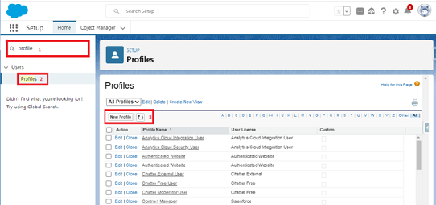

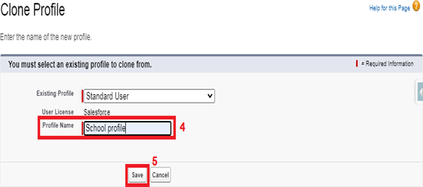

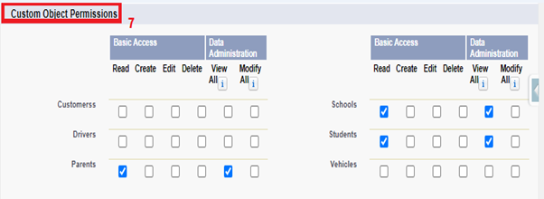

**Users**

A user is anyone who logs in to Salesforce. Users are employees at your company, such as sales reps, managers, and IT specialists, who need access to the company's records. Every user in Salesforce has a user account.

* Creating A User
* From Setup, in the Quick Find box, enter Users.
* Select Users.
* Click New User.
* Enter the user’s name Parents and (Your) email address and a unique username in the form of an email address. By default, the username is the same as the email address.
* Select a User License as salesforce.
* NOTE- As Salesforce license can only be used by 2 Users at a time in Dev Org, so If you don’t find salesforce license then deactivate a user who has salesforce license or change the license type from Salesforce to any other.
* Select a profile as a School profile.
* Check Generate new password and notify the user immediately to have the user’s login name and a temporary password emailed to your email.
* Similarly follow the above steps and create 2 users as Teachers and principals.

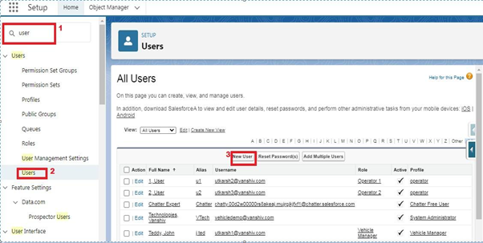

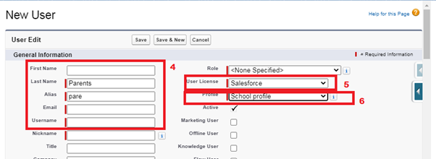

**Permission Sets**

A permission set is a collection of settings and permissions that give users access to various tools and functions. Permission sets extend users' functional access without changing their profiles.

* Permission Sets 1

1. From Setup, enter Permission Sets in the Quick Find box, then select Permission Sets.
2. Click New.
3. Give the name of the Permission set name as teacher permission.
4. Under the object settings give the view create and edit permissions to all 3 custom objects (By click open the object)
5. Click on manage assignment
6. Click on add assignment.
7. Click on Teacher (user), Next, Assign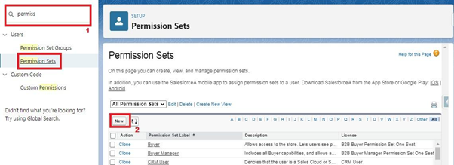n.

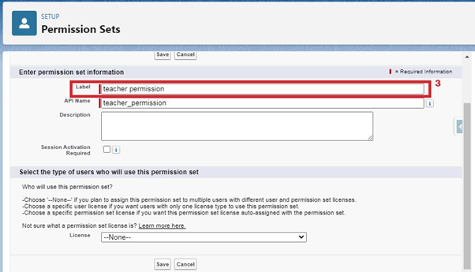

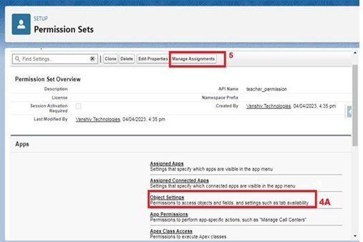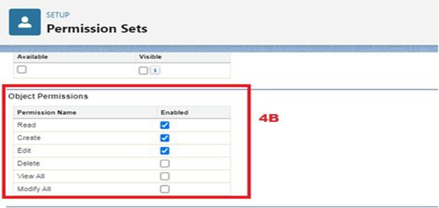



Similarly, follow the above steps for the permission set 2.

* Permission Sets 2

1. From Setup, enter Permission Sets in the Quick Find box, then select Permission Sets.
2. Click New.
3. Give the name of the Permission set name as Principal permission and then under the object settings give all permissions for the all 3 custom objects and assign them to the Principal user.

It is the most complex report format. Matrix report summarizes information in a grid format. It allows records to be grouped by both columns and rows. It can also be used to generate dashboards. Charts can be added to this type of report.

4.Joined Reports:

These types of reports let us create different views of data from multiple report types. The data is joined reports are organized in blocks. Each block acts as a subreport with its own fields, columns, sorting, and filtering. They are used to group and show data from multiple report types in different views.

There are 4 **User Adoption**

* Create Record (School)

1. Click on App Launcher on left side of screen.
2. Search School Management App & click on it.
3. Click on Schools tab.
4. Click new button
5. Fill all School record details.
6. Click on Save Button

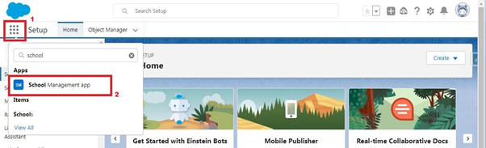

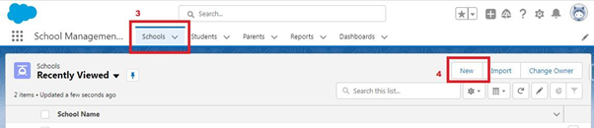

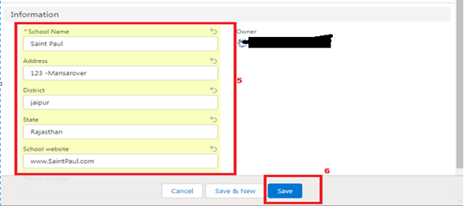

* View Record (School)

1. Click on App Launcher on left side of screen.
2. Search School Management App & click on it.
3. Click on Schools Tab.
4. Click on any record name. you can see the details of the School.



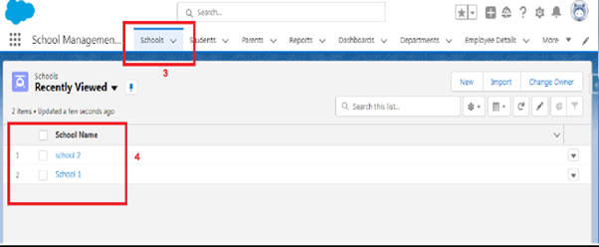

* Delete Record (School)

1. Click on App Launcher on left side of screen.
2. Search School Management App & click on it.
3. Click on Schools Tab.
4. Click on Arrow at right hand side on that Particular record.
5. Click delete and delete again.



